21. Pandas Program to Swap the Cases of a Specified Character Column

Aim
To write a Pandas program to swap the uppercase and lowercase cases of a specified character column in a DataFrame.

Algorithm
- Import the Pandas library.
- Create a DataFrame containing character/string values.
- Select the required character column.
- Use the swapcase() function to change uppercase letters to lowercase and lowercase letters to uppercase.
- Display the original and modified DataFrame.

Python Program
import pandas as pd

# Create DataFrame
data = {
'Name': ['John', 'PRIYA', 'RaVi', 'ANU'],
'Department': ['CSE', 'ece', 'Mech', 'IT']
}

df = pd.DataFrame(data)

print("Original DataFrame:")
print(df)

# Swap cases of the Name column
df['Name'] = df['Name'].str.swapcase()

print("\nDataFrame after swapping cases:")
print(df)

Input
Original DataFrame:

Name Department
0 John CSE
1 PRIYA ece
2 RaVi Mech
3 ANU IT

Output
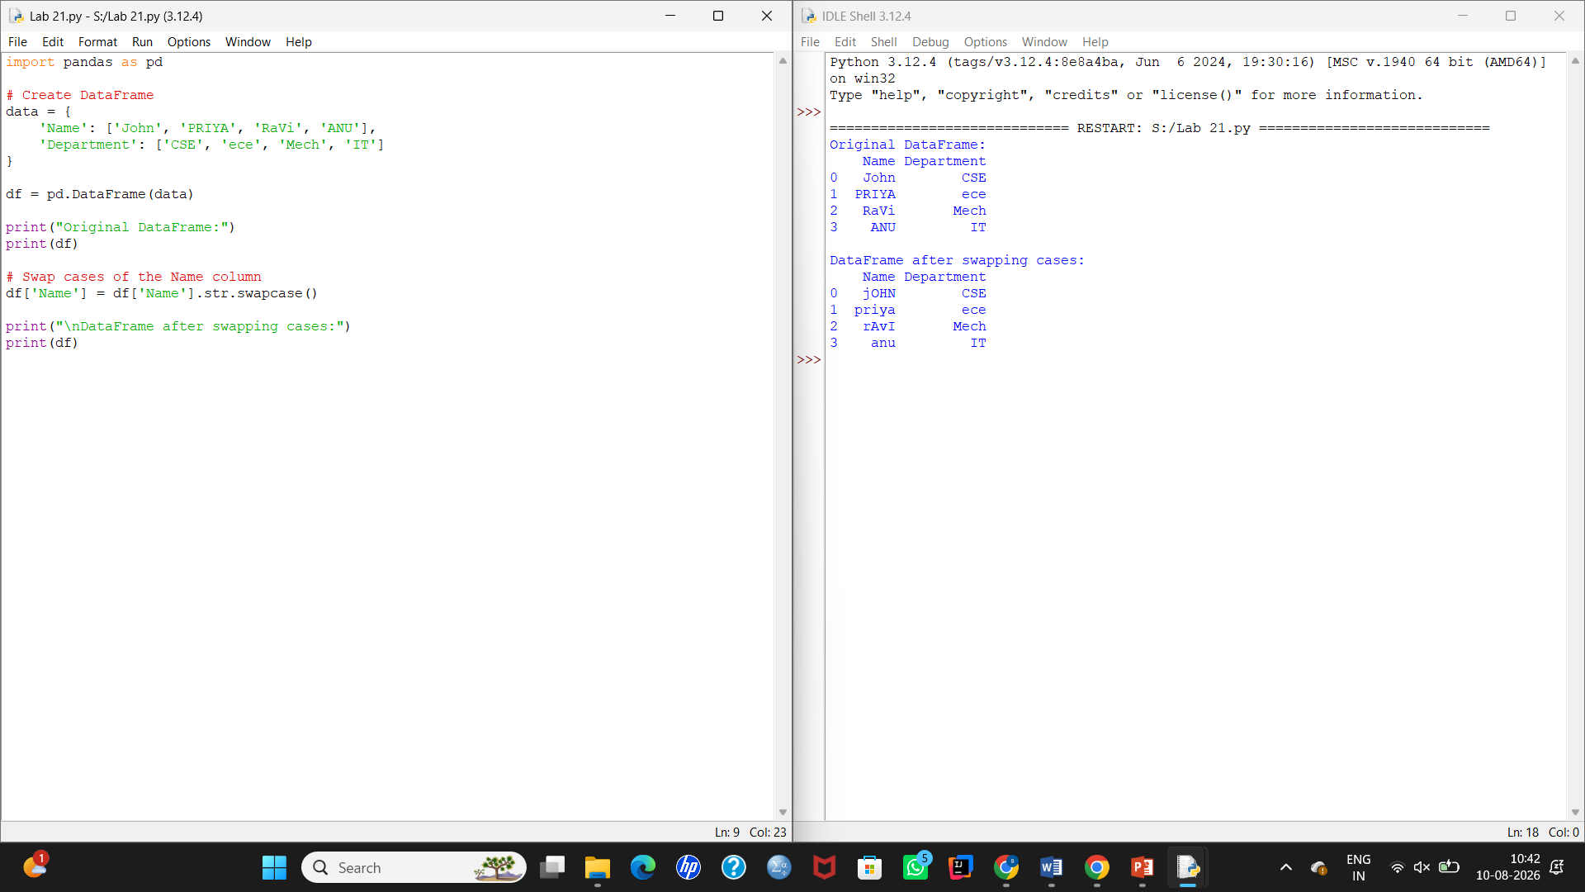

22. Draw a Line Using Given Axis Values

Aim
To write a Python program to draw a line using x-axis and y-axis values, with suitable labels for the x-axis, y-axis, and title.

Algorithm
- Import the matplotlib.pyplot library.
- Create two lists containing x-axis and y-axis values.
- Plot the values using plt.plot().
- Give a label to the x-axis.
- Give a label to the y-axis.
- Add a suitable title.
- Display the graph using plt.show().

Python Program
import matplotlib.pyplot as plt

# Given axis values
x = [1, 2, 3]
y = [2, 4, 1]

# Draw line
plt.plot(x, y)

# Labels and title
plt.xlabel("x - axis")
plt.ylabel("y - axis")
plt.title("Draw a line")

# Display graph
plt.show()

Input
x-axis y-axis

1 2
2 4
3 1
Or:
x = [1, 2, 3]
y = [2, 4, 1]

Output
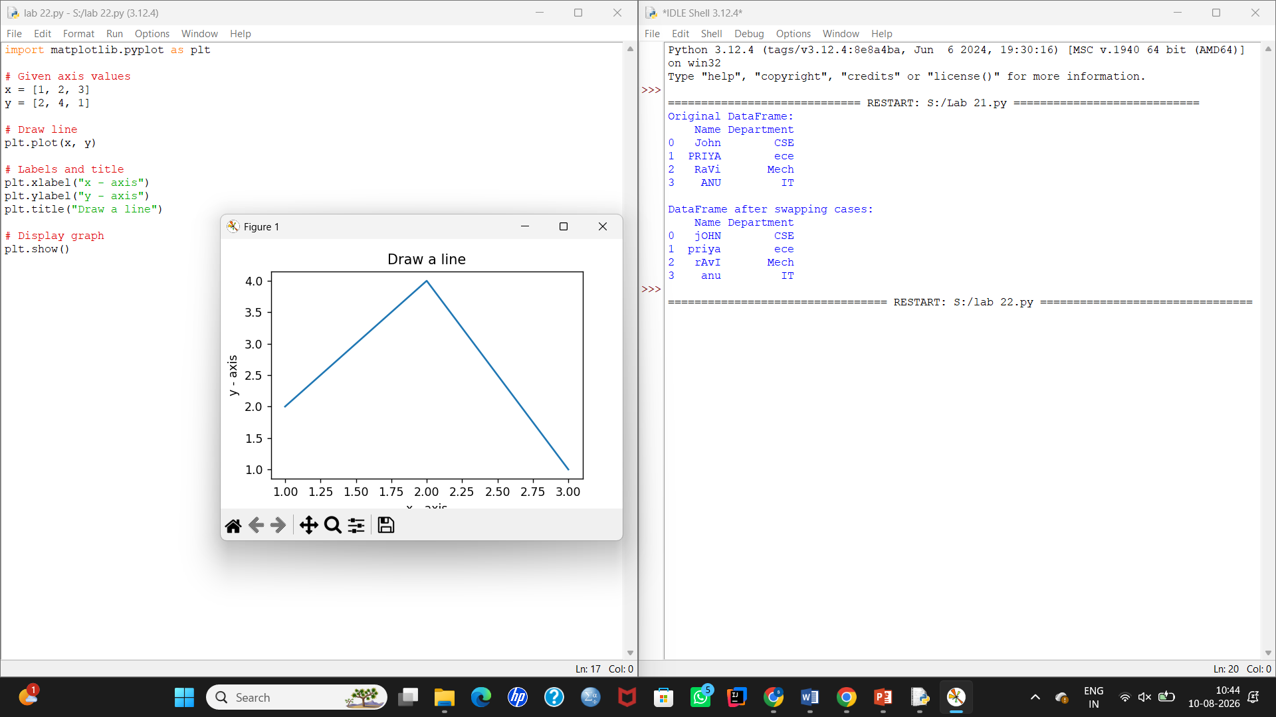

23. Draw a Line Using Axis Values from a Text File

Aim
To write a Python program to read x-axis and y-axis values from a text file and draw a line graph with suitable x-axis label, y-axis label, and title.

Algorithm
- Import the matplotlib.pyplot library.
- Create a text file named test.txt.
- Store the x and y values in the text file.
- Open the text file using open().
- Read each line and split the x and y values.
- Store the values in separate x and y lists.
- Plot the line using plt.plot().
- Set the x-axis label as x - axis.
- Set the y-axis label as y - axis.
- Set the title as Draw a line.
- Display the graph using plt.show().

Input — test.txt
Create a file named test.txt in the same folder where you save the Python program.
1 2
2 4
3 1

Python Program
import matplotlib.pyplot as plt

x = []
y = []

# Open and read the text file
with open("test.txt", "r") as file:
for line in file:
values = line.split()
x.append(int(values[0]))
y.append(int(values[1]))

# Draw the line
plt.plot(x, y)

# Add labels and title
plt.xlabel("x - axis")
plt.ylabel("y - axis")
plt.title("Draw a line")

# Display the graph
plt.show()

Output
